MENTAL HEALTH WELL-BEING

PROJECT REPORT

SUBMITTED BY
SHREYA BHUSHAN (25BCE11294)

TABLE OF CONTENTS

S. No. | Section
1 | Title Page
2 | Certificate
3 | Acknowledgment
4 | Table of Contents
5 | Introduction
6 | Objective/ Target Audience/ Importance
7 | Goals / Key Features / Key Considerations
8 | Technology Stack
9 | System Design
10 | Code
11 | Project Workflow / Website Preview
12 | Future Scope
13 | Conclusion
14 | Refrences

INTRODUCTION

Stress has become one of the most common mental health challenges in modern life, especially among students and working individuals. Factors such as lack of sleep, excessive screen time, reduced physical activity, social isolation, and emotional instability all contribute to rising stress levels. Early identification of stress is essential because unmanaged stress can negatively affect productivity, relationships, and overall well-being.
This project focuses on developing a machine learning–based Stress Level Predic tion System that analyzes lifestyle patterns and emotional factors to determine whether a person’s stress level is Low, Moderate, or High. The system uses userprovided inputs such as sleep duration, phone usage, exercise frequency, social interaction, caffeine intake, and mood. These features are processed through a trained machine learning model that predicts the stress category with good accuracy.
To make the solution practical and interactive, a simple web-based application is created using Flask. The interface allows users to take a short test, submit their responses, and instantly receive:
- Their predicted stress level, and
- Personalized suggestions to help reduce or manage stress.
This project demonstrates how technology and machine learning can be used to support mental well-being in a user-friendly and accessible manner. The goal is not just to predict stress but to offer meaningful insights that empower individuals to improve their daily habits and maintain better mental health.

OBJECTIVES

- To provide meaningful insights into Mental health well-being, stress level and improvement tips according to that.
- To identify patterns between factors such as sleep hours, workload and mood etc.
- To analyze survey responses related to mental health and daily habits.
- To apply machine learning techniques and libraries to predict stress level.

The project focuses on analyzing survey data related to mental health and well- being. The goal is to understand factors affecting mood, stress levels, and overall mental health using machine learning algorithms

TARGET AUDIENCE

- Students and Working Professionals: Those experiencing stress, anxiety or sleep issues due to workload or academic pressure.
- Individuals Interested in Mental Wellness: Anyone who wants to track their emotional health, understand stress triggers, and get personalized suggestions can benefit from this tool.
- Counselors & Mental Health Educators: Teachers, trainers, and wellness mentors can use this project as a demonstration of how technology and machine learning can support early stress detection.

IMPORTANCE

- Early Detection of Mental Health Issues: Identify early warning signs of stress before they become serious problems.
- Improved Awareness: Encourage Mental Health and make as important as physical health
- Social Impact: Contributes to building a healthier and more emotionally balanced society by promoting early care of mental health.
- Predictive Capability: The model can Predict mood or stress levels, helping users take preventive actions for maintaining good mental health

GOALS

- To Predict Stress Levels Using Machine Learning: Develop a reliable ML model capable of classifying stress levels (Low, Moderate, High) based on lifestyle and emotional factors

- To Identify Key Factors Affecting Stress: Analyze how variables like sleep, phone
usage, exercise, social interaction, and mood influence stress levels in individuals.

- To Provide Personalized Stress-Reduction Suggestions: Offer meaningful and
practical recommendations based on the predicted stress category to help users improve their mental well-being.

- To Build a Simple and Interactive Web Application: Create a user-friendly website using Flask that allows users to:
- Take the stress test
- Submit their information
- View their stress prediction
- Receive helpful guidance
- To Promote Awareness About Mental Health: Encourage users, especially
students and young adults, to understand their daily habits and how these affect their stress levels.

- To Demonstrate Practical Use of Machine Learning: Show how ML techniques can be applied to real-life problems and integrated with web development for an end-to-end solution.

KEY FEATURES

- Machine Learning–Based Stress Prediction: Uses a trained Random Forest model to accurately classify stress levels as Low, Moderate, or High based on user lifestyle and emotional factors.

- User-Friendly Web Interface: The project includes a simple Flask-based website with:
- Home page
- Test form
- Result page
This makes the system easy to access and interact with.
- Personalized Stress Reduction Suggestions: After predicting the stress level, the system provides custom tips and recommendations to help the user manage or reduce stress.

- Multi-Factor Input Analysis: The model analyzes various daily-life parameters such as:
- Sleep hours
- Phone usage
- Exercise rate
- Social interaction
- Caffeine intake
- Mood
- Gender and age
This improves prediction quality.
- Secure & Local Processing: All computations happen locally on the user’s device when the project is run outside Colab, ensuring privacy and secure data handling.

- Real-Time Output: Users get instant stress level predictions and recommendations immediately after submitting the form.

KEY CONSIDERATIONS

- Data Collection and loading 
- Data Preprocessing 
- Exploratory Data Analysis 
- Model Interpretability 
- Performance Evaluation. 
- Result Comparison 
- Webpage deployment 

TECHNOLOGY STACK

- Python: The primary programming language used for data analysis, model development, and visualization. 
- Pandas: A powerful library for data manipulation and analysis. 
- NumPy: A library for numerical operations, especially array and matrix operations. 
- Matplotlib & Seaborn: A versatile plotting library for creating static, animated, with high- level data visualization library providing a more attractive and informative visualization style. 
- Scikit learn: Implementing machine learning algorithms like Logistic Regression,
Random Forest, SVM, Naive Bayes, and KNN. 
- Flask: Flask is a lightweight web framework in Python used to build web applications - everything from simple APIs to full websites. 
- Ngrok: Ngrok is a handy little tool that lets us expose our local server to the internet securely — perfect for testing or sharing projects that are running only on our computer.
- Google colab: Google Colab is cloud-based coding notebook that lets you write and run Python—including machine learning, data science, and AI code—without installing anything on your laptop.
- Jupiter Notebook: Jupyter Notebook is an open-source application that lets you write code, run it, visualize data, and add text all in one place.

SYSTEM DESIGN

- USE CASE DIAGRAM
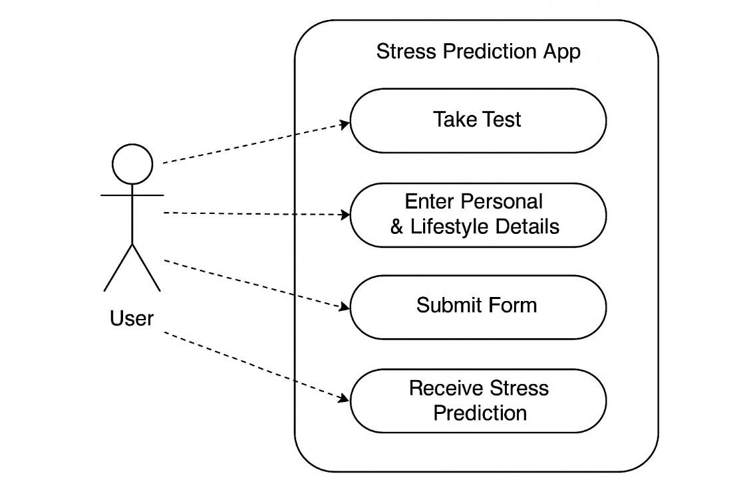
- ER DIAGRAM
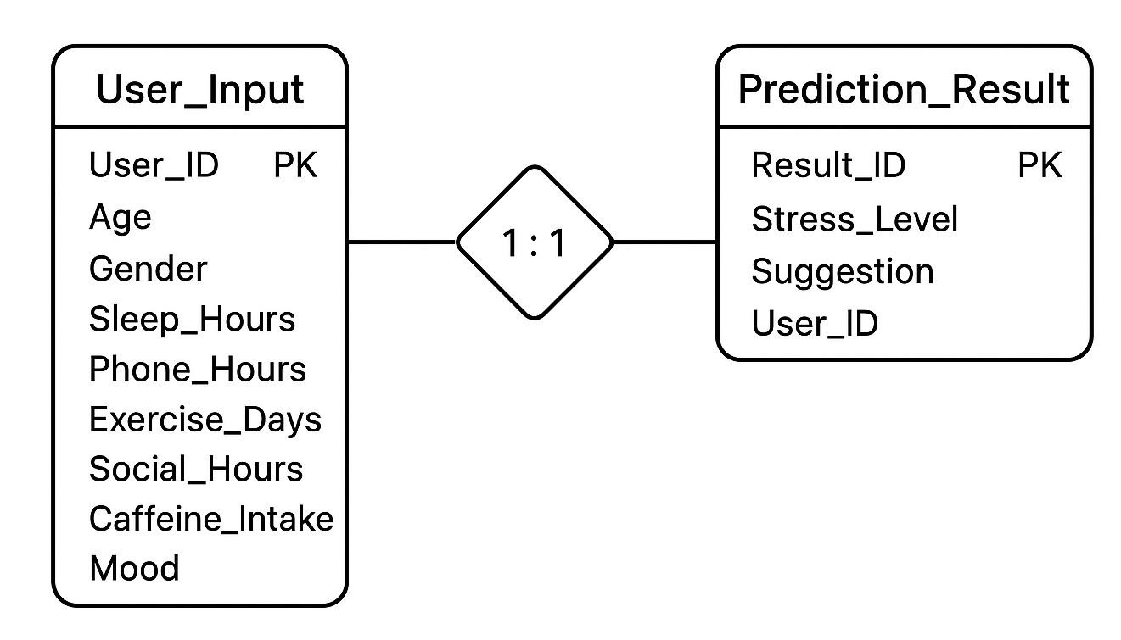

CODE

from google.colab import drive
drive.mount('/content/drive')

_____________________________________________
# Step 0 - Install required libs (run in Colab)
!pip install -q scikit-learn pandas flask-ngrok pyngrok joblib flask

# basic imports
import os
import pandas as pd
import numpy as np
from sklearn.model_selection import train_test_split
from sklearn.ensemble import RandomForestClassifier
from sklearn.preprocessing import OrdinalEncoder, LabelEncoder
from sklearn.metrics import classification_report, confusion_matrix, accuracy_score
import joblib

print("Setup done. Ready to load data.")

_____________________________________________
# Step 1 - Load your Google Sheet into pandas

df = pd.read_csv("/content/drive/MyDrive/Mental health.csv")
print("Loaded rows:", len(df))
df.head(6)
_____________________________________________
# Step 2 - Quick EDA and cleaning
df.columns = [c.strip() for c in df.columns] # tidy column names
print("Columns:", df.columns.tolist())

# Show counts and missing values
print(df.info())
print("\nMissing values per column:\n", df.isna().sum())

# If Timestamp column exists and is parsed as string, keep as-is (not required for model).
# Drop rows with missing target (if any) -- we'll assume "How much stress you take in your workload?" is the target.
target_col = [c for c in df.columns if 'stress' in c.lower() or 'workload' in c.lower()]
print("Detected target column candidates:", target_col)
_____________________________________________
# Step 3 - Feature selection + encoding maps
# Update these keys to match exact column names from df.columns output
col_sleep = "How many hours do you sleep daily"
col_phone = "How many hours do you spend on your phone per day?"
col_exercise = "How often do you exercise?"
col_social = "How many hours per week do you spend with friends or family (social interaction) ?"
col_caffeine = "How much caffeine (tea/coffee)?"
col_mood = "How would you describe your current mood?"
col_workload_stress = "How much stress you take in your workload?"

# Sanity-check: make sure columns exist
for c in [col_sleep, col_phone, col_exercise, col_social, col_caffeine, col_mood, col_workload_stress]:
if c not in df.columns:
raise KeyError(f"Column not found in sheet: {c}")

# Example ordinal maps (tune as you like)
sleep_map = {
"Less than 4 hours": 0,
"4-5 hours": 1,
"5-6 hours": 2,
"6-8 hours": 3,
"more than 8 hours": 4,
"More than 8 hours": 4 # handle capitalization variants
}

phone_map = {
"Less than 1 hour": 0,
"1-2 hours": 1,
"2-4 hours": 2,
"4-6 hours": 3,
"6-8 hours": 4,
"More than 8 hours": 5,
"more than 8 hours": 5
}

exercise_map = {
"Never": 0,
"Rarely": 1,
"Monthly": 2,
"Weekly": 3,
"Daily": 4
}

social_map = {
"0-2 hours": 0,
"3-5 hours": 1,
"6- 10 hours": 2,
"6-10 hours": 2,
"More than 10 hours": 3,
"More than 10 hours ": 3
}

caffeine_map = {
"Nil": 0,
"1-2": 1,
"1-2 ": 1,
"1-2 ": 1,
"More than 2": 2,
"More than 2 ": 2
}

mood_map = {
"Happy": 3,
"Neutral": 2,
"Sad": 1,
"Exhausted Right now": 0,
"Currently I'm confused as things I planned for this week are not going as planned... Looking up for loopholes": 1
}

stress_map = {
"Not at all": 0,
"Minimal": 1,
"Mild": 2,
"Moderate": 3,
"Severe": 4,
"Right now Moderate": 3,
"Not at all ": 0
}

# Create a copy and apply maps safely (use .map and fillna with -1 for unknown)
df_model = df.copy()
df_model['sleep_num'] = df_model[col_sleep].map(sleep_map).fillna(-1).astype(int)
df_model['phone_num'] = df_model[col_phone].map(phone_map).fillna(-1).astype(int)
df_model['exercise_num'] = df_model[col_exercise].map(exercise_map).fillna(-1).astype(int)
df_model['social_num'] = df_model[col_social].map(social_map).fillna(-1).astype(int)
df_model['caffeine_num'] = df_model[col_caffeine].map(caffeine_map).fillna(-1).astype(int)
df_model['mood_num'] = df_model[col_mood].map(mood_map).fillna(2).astype(int) # assume neutral if unknown

# Target
df_model['stress_num'] = df_model[col_workload_stress].map(stress_map).fillna(2).astype(int)

# Show a small sample of transformed columns
df_model[['sleep_num','phone_num','exercise_num','social_num','caffeine_num','mood_num','stress_num']].head(8)

_____________________________________________

# Step 4 - train/test split and model training
features = ['sleep_num','phone_num','exercise_num','social_num','caffeine_num','mood_num']
X = df_model[features].values
y = df_model['stress_num'].values

# Remove rows where some feature is -1 (unknown mapping) to keep training clean
mask = (X != -1).all(axis=1)
X = X[mask]
y = y[mask]

X_train, X_test, y_train, y_test = train_test_split(X, y, test_size=0.2, random_state=42, stratify=y)

clf = RandomForestClassifier(n_estimators=200, random_state=42)
clf.fit(X_train, y_train)

# Evaluate
y_pred = clf.predict(X_test)
print("Accuracy:", accuracy_score(y_test, y_pred))
print(classification_report(y_test, y_pred))
print("Confusion matrix:\n", confusion_matrix(y_test, y_pred))
_____________________________________________

# Step 5 - Save model and encoder objects
model_path = "/content/stress_model.joblib"
joblib.dump({
"model": clf,
"features": features,
"sleep_map": sleep_map,
"phone_map": phone_map,
"exercise_map": exercise_map,
"social_map": social_map,
"caffeine_map": caffeine_map,
"mood_map": mood_map,
"stress_map": stress_map
}, model_path)

print("Saved model artifacts to", model_path)
_____________________________________________

!pip install flask flask-ngrok scikit-learn pandas

_____________________________________________

app_py = r'''
from flask import Flask, render_template, request, jsonify
import joblib
import numpy as np

app = Flask(__name__)
artifact = joblib.load("/content/stress_model.joblib")
model = artifact['model']

# reverse maps for display
rev_stress = {v:k for k,v in artifact['stress_map'].items()}

# helper to map inputs (same maps used during training)
def safe_map(val, mapping, default=0):
# try exact match then lower-case versions
if val in mapping:
return mapping[val]
if isinstance(val, str) and val.strip() in mapping:
return mapping[val.strip()]
if isinstance(val, str) and val.lower().strip() in mapping:
return mapping[val.lower().strip()]
return default

# --- Improvement Tips ---
def get_recommendations(sleep, phone, exercise, social, caffeine, mood, stress_label):
tips = []

# Sleep
if "Less" in sleep or "4" in sleep:
tips.append("Try to sleep 7–8 hours daily. A consistent sleep schedule greatly reduces stress hormones.")
elif "5-6" in sleep:
tips.append("You’re close! Aim for a full 7–8 hours of quality sleep for better emotional balance.")

# Phone usage
if "6" in phone or "8" in phone or "More" in phone:
tips.append("Reduce phone screen time, especially before bed — blue light can worsen stress and sleep quality.")

# Exercise
if exercise in ["Never", "Rarely"]:
tips.append("Start light physical activity 3–4 times a week — exercise helps release stress-relieving endorphins.")

# Social interaction
if "0-2" in social or "3-5" in social:
tips.append("Spend more time with friends or family — social support is one of the strongest stress buffers.")

# Caffeine
if "More" in caffeine or caffeine.strip() == "2":
tips.append("Cut down caffeine intake to 1–2 cups max daily. Excess caffeine triggers anxiety and restlessness.")

# Mood
if mood in ["Sad", "Exhausted Right now"]:
tips.append("Take short breaks, listen to calming music, or meditate for 10 minutes to reset your mind.")

# Stress-specific tip
if stress_label in ["Moderate", "Severe"]:
tips.append("You seem to be under noticeable stress. Journaling or deep breathing exercises can help a lot.")
elif stress_label in ["Mild", "Minimal"]:
tips.append("You’re doing well! Keep maintaining balance and consistency in your daily routine.")
elif stress_label == "Not at all":
tips.append("Great! Maintain your healthy habits to keep stress at bay.")

return tips

@app.route('/')
def home():
return render_template('home.html')

@app.route('/predict form')
def index():
return render_template('index.html')

@app.route('/predict', methods=['POST'])
def predict():
try:
sleep = request.form.get('sleep', '')
phone = request.form.get('phone', '')
exercise = request.form.get('exercise', '')
social = request.form.get('social', '')
caffeine = request.form.get('caffeine', '')
mood = request.form.get('mood', '')

sleep_n = safe_map(sleep, artifact['sleep_map'], default=0)
phone_n = safe_map(phone, artifact['phone_map'], default=0)
exercise_n = safe_map(exercise, artifact['exercise_map'], default=0)
social_n = safe_map(social, artifact['social_map'], default=0)
caffeine_n = safe_map(caffeine, artifact['caffeine_map'], default=0)
mood_n = safe_map(mood, artifact['mood_map'], default=2)

x = np.array([[sleep_n, phone_n, exercise_n, social_n, caffeine_n, mood_n]])
pred = model.predict(x)[0]
label = rev_stress.get(pred, str(pred))
recommendations = get_recommendations(sleep, phone, exercise, social, caffeine, mood, label)

return render_template('result.html', label=label, recommendations=recommendations)

except Exception as e:
return str(e), 400

if __name__ == '__main__':
app.run(debug=True ,port=5000)
'''

# Templates (index.html and result.html)
home_html = r'''
<!doctype html>
<html>
<head>
<meta charset="utf-8" />
<title>Welcome | Stress Level Predictor</title>
<style>
body {
font-family: Arial, sans-serif;
background: #fedada;
color: #333;
padding: 50px;
text-align: center;
}
.container {
background: white;
border-radius: 14px;
max-width: 700px;
margin: auto;
padding: 40px;
box-shadow: 0 8px 22px rgba(0,0,0,0.1);
}
h1 { color: #cc8787; margin-bottom: 10px; }
p { font-size: 18px; color:#555; }
a.button {
display: inline-block;
margin-top: 30px;
background: #cc8787;
color: white;
padding: 14px 24px;
text-decoration: none;
font-weight: bold;
border-radius: 10px;
transition: background 0.3s;
}
a.button:hover { background: #b46969; }
</style>
</head>
<body>
<div class="container">
<h1>Welcome to the Stress Level Predictor</h1>
<p>Take a short test to find out your current stress level</p>
<a href="/predict form" class="button">Take Test</a>
</div>
</body>
</html>
'''

index_html = r'''
<!doctype html>
<html>
<head>
<meta charset="utf-8" />
<title>Stress Level Predictor</title>
<style>
body { font-family: Arial, sans-serif; background: #fedada; color: #333; padding: 30px; }
.card { background: white; border-radius: 12px; padding: 22px; max-width: 640px; margin: auto; box-shadow: 0 6px 18px rgba(0,0,0,0.08); }
h1 { color: #cc8787; text-align: center; }
label { display:block; margin-top:12px; font-weight:600; }
select, input { width: 100%; padding: 10px; border-radius: 8px; border: 1px solid #eee; margin-top:6px; box-sizing:border-box; }
button { margin-top: 16px; width: 100%; background: #cc8787; color: white; padding: 12px; border: none; border-radius: 10px; font-weight:700; cursor:pointer; }
small { color:#666; }
</style>
</head>
<body>
<div class="card">
<h1>Stress Level Predictor</h1>
<form action="/predict" method="post">
<label>How many hours do you sleep daily?</label>
<select name="sleep">
<option>Less than 4 hours</option>
<option>5-6 hours</option>
<option>6-8 hours</option>
<option>more than 8 hours</option>
</select>

<label>Phone usage per day</label>
<select name="phone">
<option>Less than 1 hour</option>
<option>1-2 hours</option>
<option>2-4 hours</option>
<option>4-6 hours</option>
<option>6-8 hours</option>
<option>More than 8 hours</option>
</select>

<label>How often do you exercise?</label>
<select name="exercise">
<option>Never</option>
<option>Rarely</option>
<option>Monthly</option>
<option>Weekly</option>
<option>Daily</option>
</select>

<label>Hours/week social interaction</label>
<select name="social">
<option>0-2 hours</option>
<option>3-5 hours</option>
<option>6-10 hours</option>
<option>More than 10 hours</option>
</select>

<label>Caffeine intake</label>
<select name="caffeine">
<option>Nil</option>
<option>1-2</option>
<option>More than 2</option>
</select>

<label>Current mood</label>
<select name="mood">
<option>Happy</option>
<option>Neutral</option>
<option>Sad</option>
<option>Exhausted Right now</option>
</select>

<button type="submit">Predict Stress</button>
</form>
<p style="margin-top:12px;"><small>Model trained from survey data. Use as a guide, not medical advice.</small></p>
</div>
</body>
</html>
'''

result_html = r'''
<!doctype html>
<html>
<head>
<meta charset="utf-8" />
<title>Stress Level Result</title>
<style>
body { font-family: 'Segoe UI', sans-serif; background: linear-gradient(135deg, #ffe5e5, #fff0f0); color: #333; padding: 30px; }
.card { background: white; border-radius: 18px; padding: 28px; max-width: 720px; margin: auto;
box-shadow: 0 6px 18px rgba(0,0,0,0.1); text-align:center; }
h1 { color: #cc7878; font-size: 32px; margin-bottom: 15px; }
.label { font-size: 24px; margin-top: 10px; font-weight:700; color:#444; }
.recommendations { margin-top: 24px; text-align: left; background:#fff6f6; padding:18px; border-radius:12px; }
.recommendations h2 { font-size: 22px; color:#cc7878; margin-bottom:10px; }
.recommendations ul { list-style-type: disc; margin-left:25px; }
a { display:inline-block; margin-top:20px; text-decoration:none; padding:12px 18px;
background:#cc7878; color:#fff; border-radius:8px; font-weight:600; transition:0.3s; }
a:hover { background:#b86c6c; }
</style>
</head>
<body>
<div class="card">
<h1>Predicted Stress Level</h1>
<div class="label">{{ label }}</div>

<div class="recommendations">
<h2>Personalized Tips to Improve Stress:</h2>
<ul>
{% for tip in recommendations %}
<li>{{ tip }}</li>
{% endfor %}
</ul>
</div>

<a href="/"> Try Again</a>
</div>
</body>
</html>
'''

# Write files
with open('/content/app.py', 'w') as f:
f.write(app_py)
os.makedirs('/content/templates', exist_ok=True)
with open('/content/templates/home.html', 'w') as f:
f.write(home_html)
with open('/content/templates/index.html', 'w') as f:
f.write(index_html)
with open('/content/templates/result.html', 'w') as f:
f.write(result_html)

print("Created Flask app at /content/app.py and templates. Next step: run with ngrok to expose on the internet (Colab).")

_____________________________________________
!pip install pyngrok

from pyngrok import ngrok

!pkill -f ngrok

ngrok.set_auth_token("35EOr3OyoG55th6ITmD2ERYF7RW_3h1bxbNHWoZZD1GrXd7Pk")

public_url = ngrok.connect(5000)
print("public_url:", public_url)

!python app.py

PROJECT WORKFLOW

Step 1: User will open the website and click on “Take test” button.
Step 2: A page with form will open, user will fill the form by choosing any option and then they need to click on “Predict Stress” button.
Step 3: After clicking, a result page will open with predicted stress level and improvement tips related to the features affecting.

WEBSITE PREVIEW

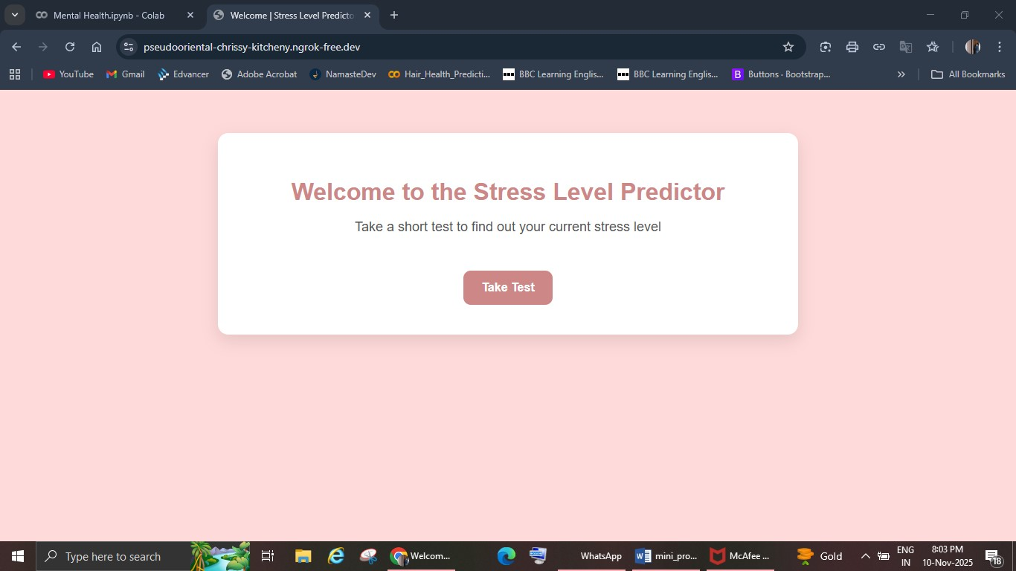
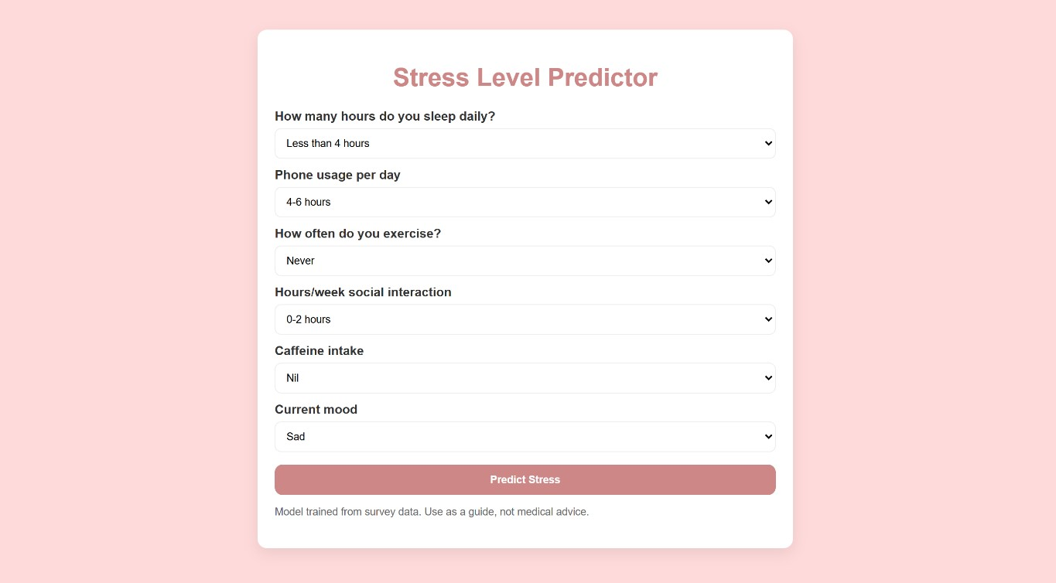

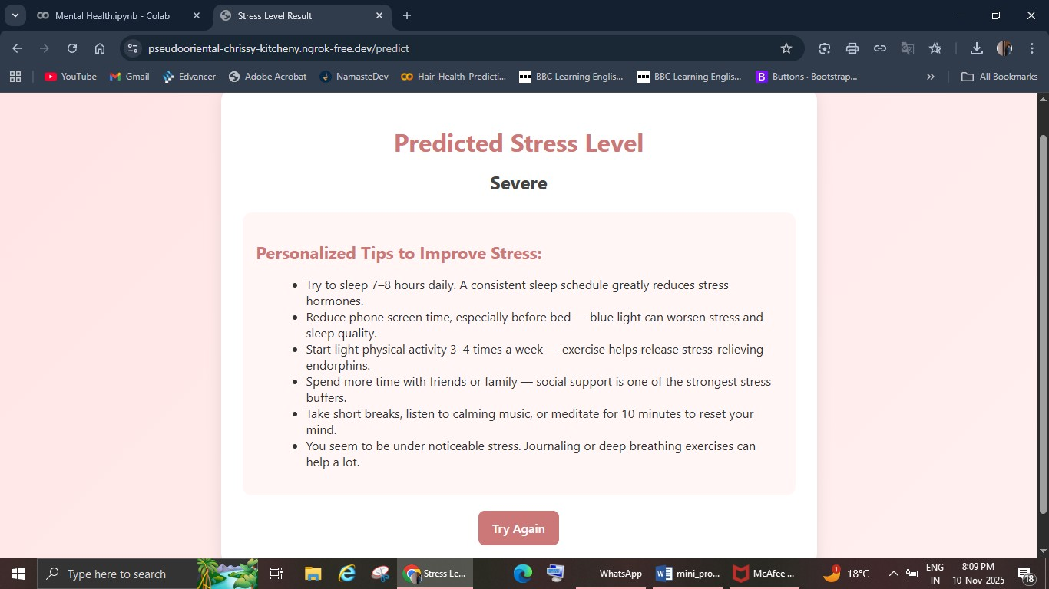

 
 
 

FUTURE SCOPE

 Real-Time Prediction System: The model can be integrated into a mobile or web application to predict mental health status in real-time based on user inputs. 
 Inclusion of Physiological Data: Future models can combine survey data with wearable device data like heart rate, sleep quality, or activity level for better insights. 
 Personalized Recommendations: The system can be enhanced to provide custom mental health tips or stress-reduction techniques based on individual responses. 
4. Collaboration with Mental Health Experts: Partnering with psychologists or wellness organizations can help validate predictions and improve the model’s reliability.
 Awareness and Education: The project can contribute to mental health awareness programs in schools, universities, and workplaces through data insights. 
6. Advanced Machine Learning Models: Implementing Deep Learning or Neural Networks could capture more complex relationships in mental health patterns.
 Larger and Diverse Dataset: Expanding the dataset with more participants from different age groups, professions, and backgrounds can improve accuracy and generalization. 
 

CONCLUSION

This project demonstrates how machine learning can be effectively applied to analyze and predict mental health conditions using survey data.
By identifying patterns between sleep, workload, and mood, the system provides valuable insights into emotional well-being.
Among the algorithms tested, Random Forest and Gradient Boosting produced the highest accuracy, proving that ensemble models are powerful for behavioral data.
Overall, the project promotes the importance of data-driven mental health awareness, early detection, and preventive care.
It serves as a foundation for developing real-time, personalized tools that support individuals in maintaining better mental health and well-being.

15

REFERENCES

• Machine Learning & Tools
- Scikit-learn Developers. Scikit-Learn Documentation.
- NumPy Developers. NumPy Library Documentation.
- Pandas Developers. Pandas Official Documentation.
- TensorFlow & Keras Documentation (if applicable).
• Web Development Tools
- Flask Framework — Official Documentation.
- Bootstrap Framework — Official Website & Docs.
- Google Colab — Official Documentation Pages.
• Dataset
1. Mental Health Dataset — Collected and curated as part of this academic project.

16

